Restore ɩ Empower ɩ Thrive

New Patient Admittance Form

Welcome to Cloverdale Chiropractic. The information you provide helps us to understand better the nature of your condition. We kindly ask that you complete this admittance form to the best of your knowledge. All information gathered will remain confidential and only be shared with those you have granted consent.

Date: ______________

Name: ____________________________________________

Address: __________________________________________

City: ________________________ Prov.: ______________ Postal Code: _____________

Home phone: __________________________ Cell phone: _________________________

Email address: (for appointment reminders) ______________________________________________

Date of birth: (DD/MMM/YYYY) ____________________________

BC MSP Healthcare #: _________________________________

Occupation: _________________________________________

Employer: ___________________________________________

Referred by: _________________________________________

Emergency contact (name and phone #): ___________________________________________

____________________________________________________________________________

Health History

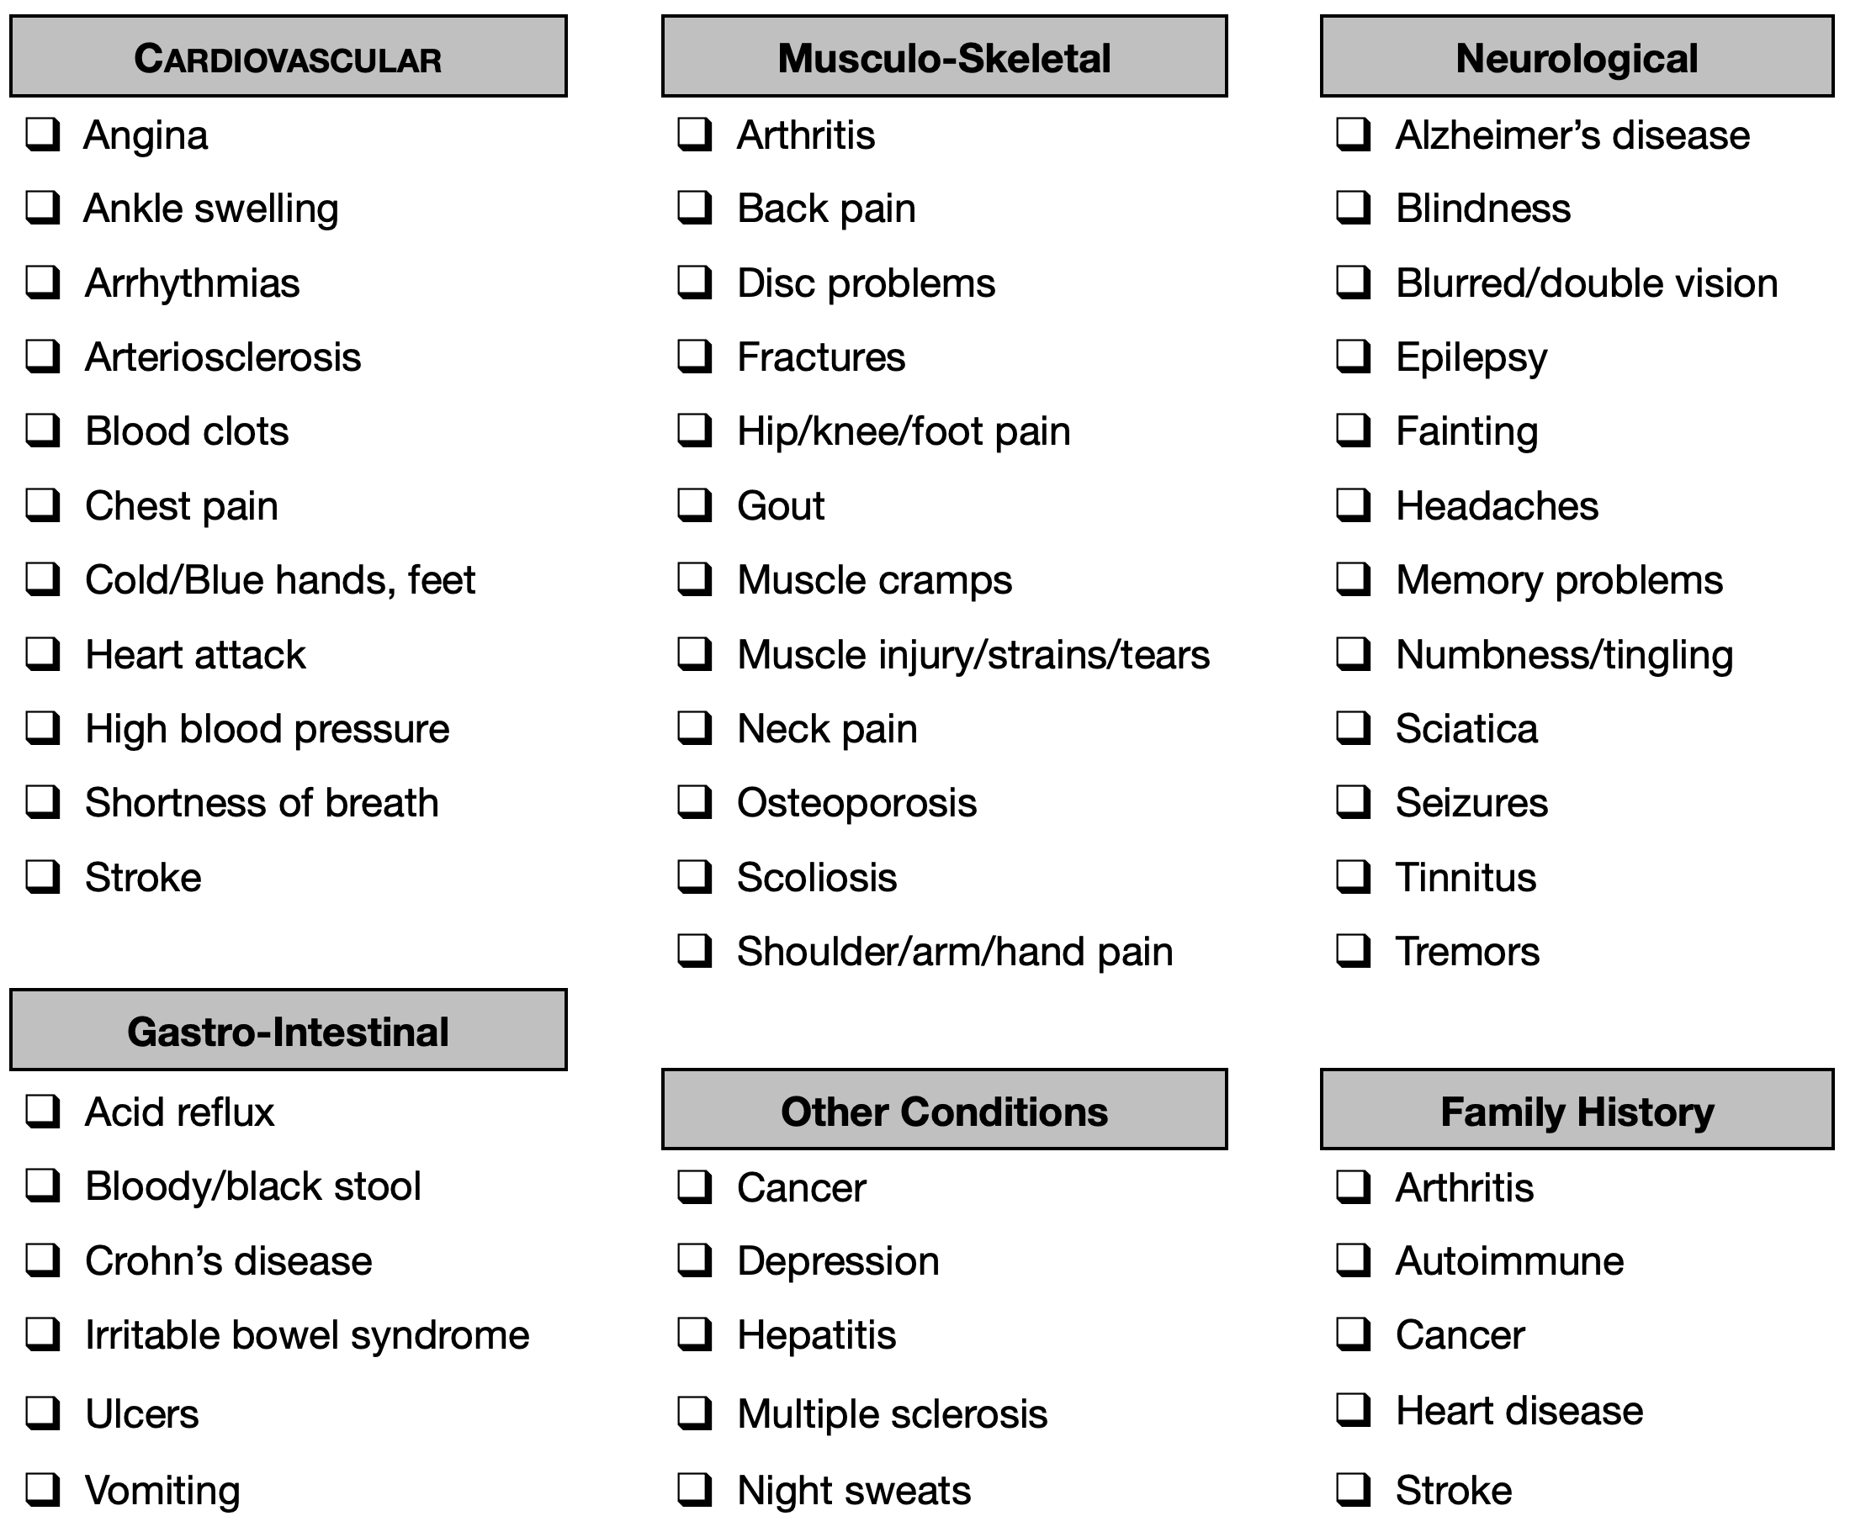

Past fractures: __________________________________________________________________________________

______________________________________________________________________________________________

Past surgeries: ___________________________________________________________________________________

_______________________________________________________________________________________________

Past hospitalizations: ______________________________________________________________________________

_______________________________________________________________________________________________

Present Condition

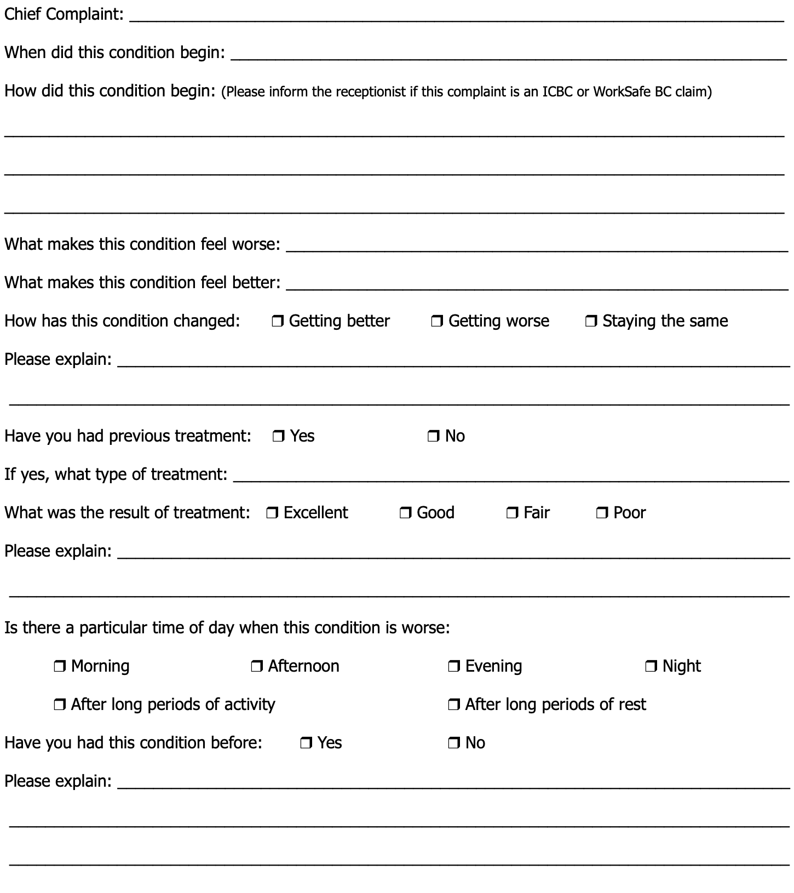
Present Condition

Place An (X) To Indicate Your Present Level Of Discomfort:

Most Severe Pain Ever
No Pain

In the diagrams below, please use the symbols provided to mark the areas on your body that best represent the symptoms that you are feeling and their locations.

Symbols: | Burning | XXXXX | Pins and Needles | / / / / / | Numbness | WWWW
 | Dull and Aching | +++++ | Stabbing and Sharp | # # # # | Stiff and Tight | : : : :

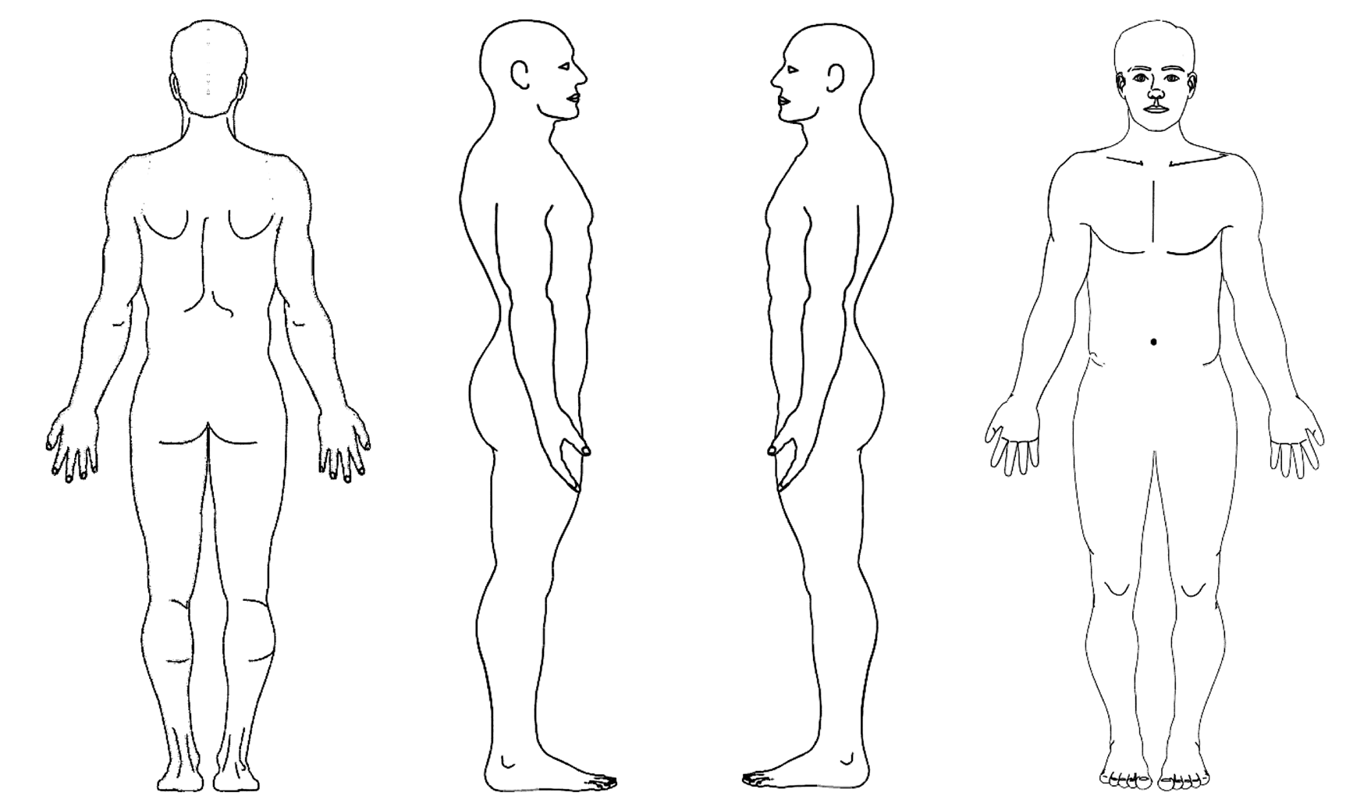

Before the examination and treatment begins, do you have any questions or concerns that you wish to discuss:

_________________________________________________________________________________________________

_________________________________________________________________________________________________

_________________________________________________________________________________________________
Informed Consent

CANADIAN CHIROPRACTIC PROTECTIVE ASSOCIATION
Informed Consent to Chiropractic Treatment FORM L

There are risks and possible risks associated with manual therapy techniques used by doctors of chiropractic. In particular, you should note:
- While rare, some patients may experience short-term aggravation of symptoms or muscle and ligament strains or sprains as a result of manual therapy techniques. Although uncommon, rib fractures have also been known to occur following certain manual therapy procedures;
- There are reported cases of stroke associated with visits to medical doctors and chiropractors. Research and scientific evidence does not establish a cause-and-effect relationship between chiropractic treatment and the occurrence of stroke. Recent studies suggest that patients may be consulting medical doctors and chiropractors when they are in the early stages of a stroke. In essence, there is a stroke already in progress. However, you are being informed of this reported association because a stroke may cause serious neurological impairment or even death. The possibility of such injuries occurring in association with upper cervical adjustment is extremely remote;
- There are rare reported cases of disc injuries identified following cervical and lumbar spinal adjustment, although no scientific evidence has demonstrated such injuries are caused, or may be caused, by spinal adjustments or other chiropractic treatment;
- There are infrequent reported cases of burns or skin irritation associated with the use of some types of electrical therapy offered by some doctors of chiropractic.
I acknowledge I have read this consent, and I have discussed, or have been offered the opportunity to discuss, with my chiropractor the nature and purpose of chiropractic treatment in general (including spinal adjustment), the treatment options and recommendations for my condition, and the contents of this Consent.
I consent to the chiropractic treatment recommended to me by my chiropractor, including any recommended spinal adjustments.
I intend this consent to apply to all my present and future chiropractic care.

Authorization For Treatment
Patient’s Name |  | Witness Name
Patient’s Signature |  | Witness Signature
Patient must be of legal age (18 years) to sign the consent
Date |  | Date
Parent of Guardian
Name of parent or legal guardian |  | Signature of parent or legal guardian
Date | Page 5

